Game Design Document

Fill up the following document

1. Write the title of your project.

Balloon buster

1. What is the goal of the game?

The goal of the game is to burst as many balloons as possible in order to win the game.

1. Write a brief story of your game.

Rohit decided to be a part of a carnival, and he has organized a balloon buster game for the people visiting there.

1. Which are the playing characters of this game?

* Playing characters are the ones who respond to the user based on the input from the user.
* Cars, monkeys, dinos, wizards, etc., are the playing characters in the game.

|  |  |  |
| --- | --- | --- |
| Number | Character Name | What can this character do? |
| 1 | Bow | Fire arrows |
| 2 |  |  |
| 3 |  |  |
| 4 |  |  |
| 5 |  |  |
| 6 |  |  |
| 7 |  |  |
| 8 |  |  |

1. Which are the Non-Playing Characters of this game?

* Non-Playing characters are the ones that don't have an action or behavior when the user interacts with the game.
* Hurdles, stones, bananas, coins, etc., are non-playing characters in the game.

|  |  |  |
| --- | --- | --- |
| Number | Character Name | What can this character do? |
| 1 | Balloons | Move forwards |
| 2 | Arrow | Destroy the balloons |
| 3 |  |  |
| 4 |  |  |
| 5 |  |  |
| 6 |  |  |
| 7 |  |  |
| 8 |  |  |

Draw your imagination of this game. What does this game look like?

* Draw the game either on your computer or on paper.
* Add images of the game scenes to show each of the playing and non-playing characters at least once.

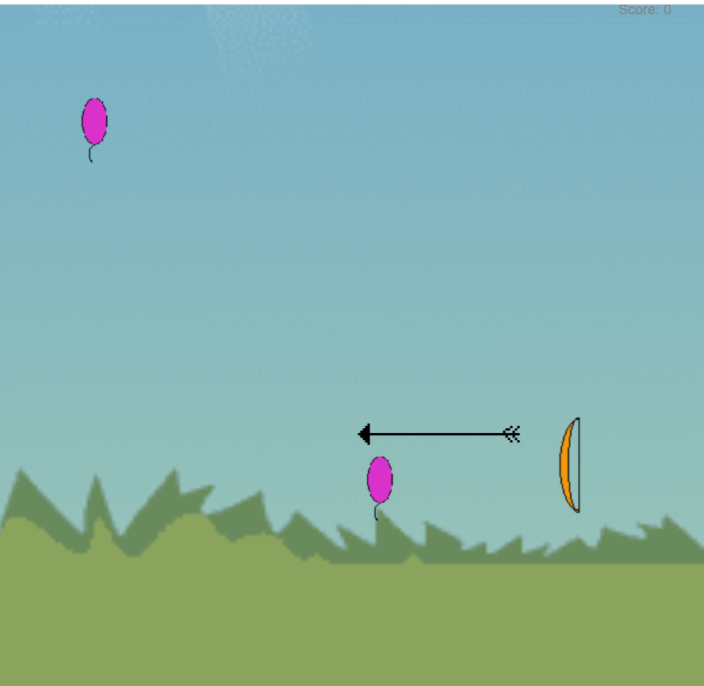

How do you plan to make your game engaging?

By providing it different difficulty levels.